Google Cloud observation

  - The bucket was created and file was uploaded into input folder. Picture - 1

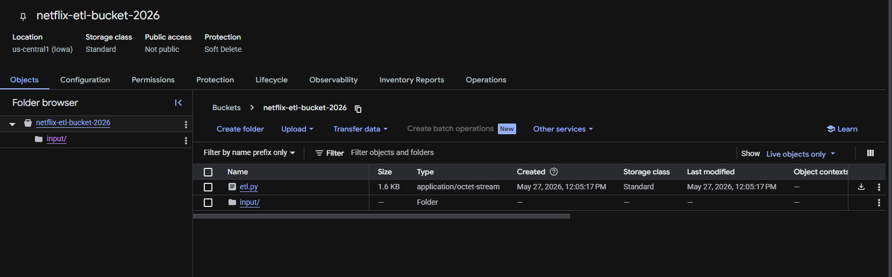
Picture -1

Here is pipeline code

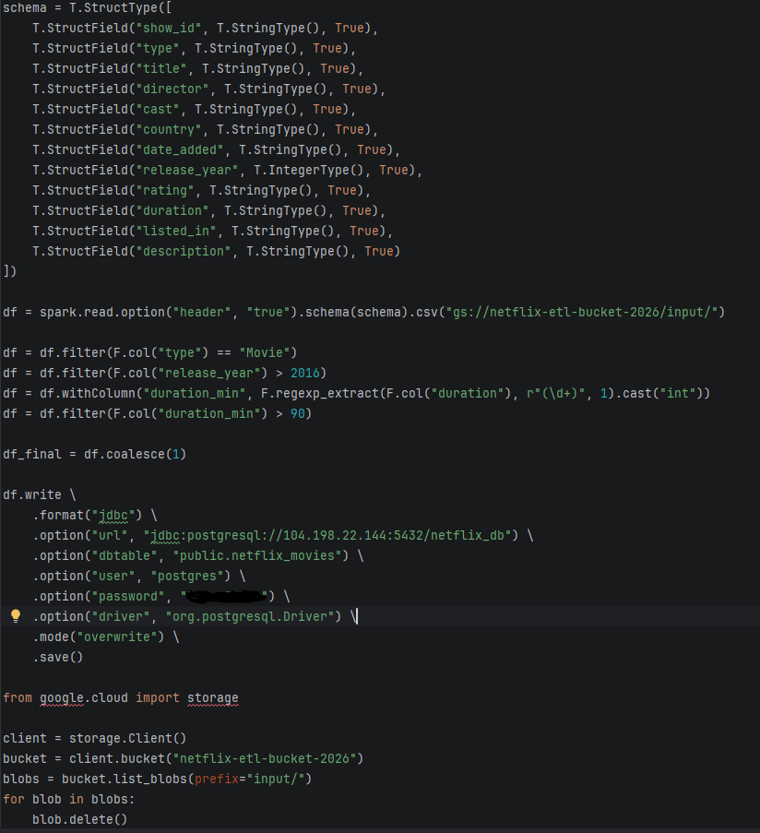

  - Instance was created (it’s a kind of server so we could deploy our services) Picture - 2

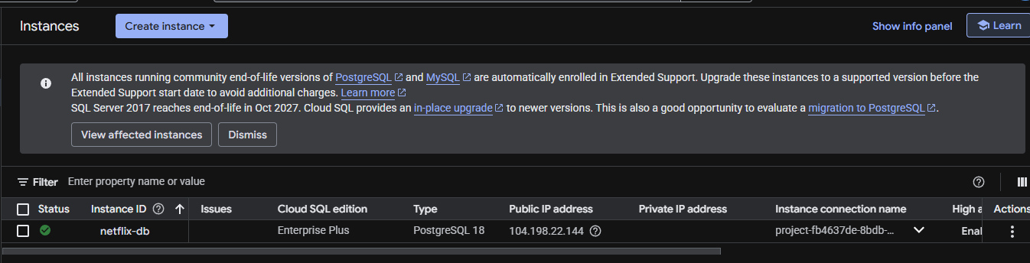
Picture - 2

  - I also created a cluster and then created a job(it’s a kind of script) It’s correct but it doesn’t work since I there is some problem with billing. But I have tried to handle it many time and have checked everything but it still doesn’t work. Perhaps it’s a bug. As a result I decided to continue my exploring process by ignoring billing mistake. Picture (3,4)

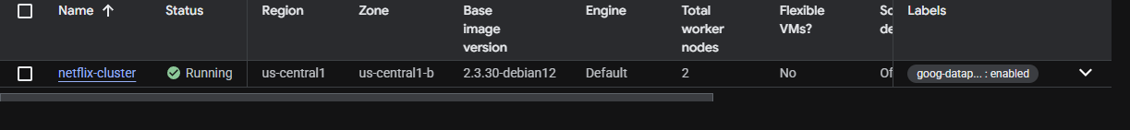
Picture 3

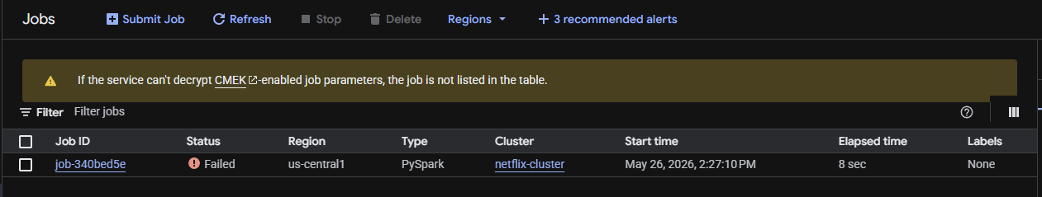
Picture 4

1.4 After that I built a Cloud run function (Pictures 5)

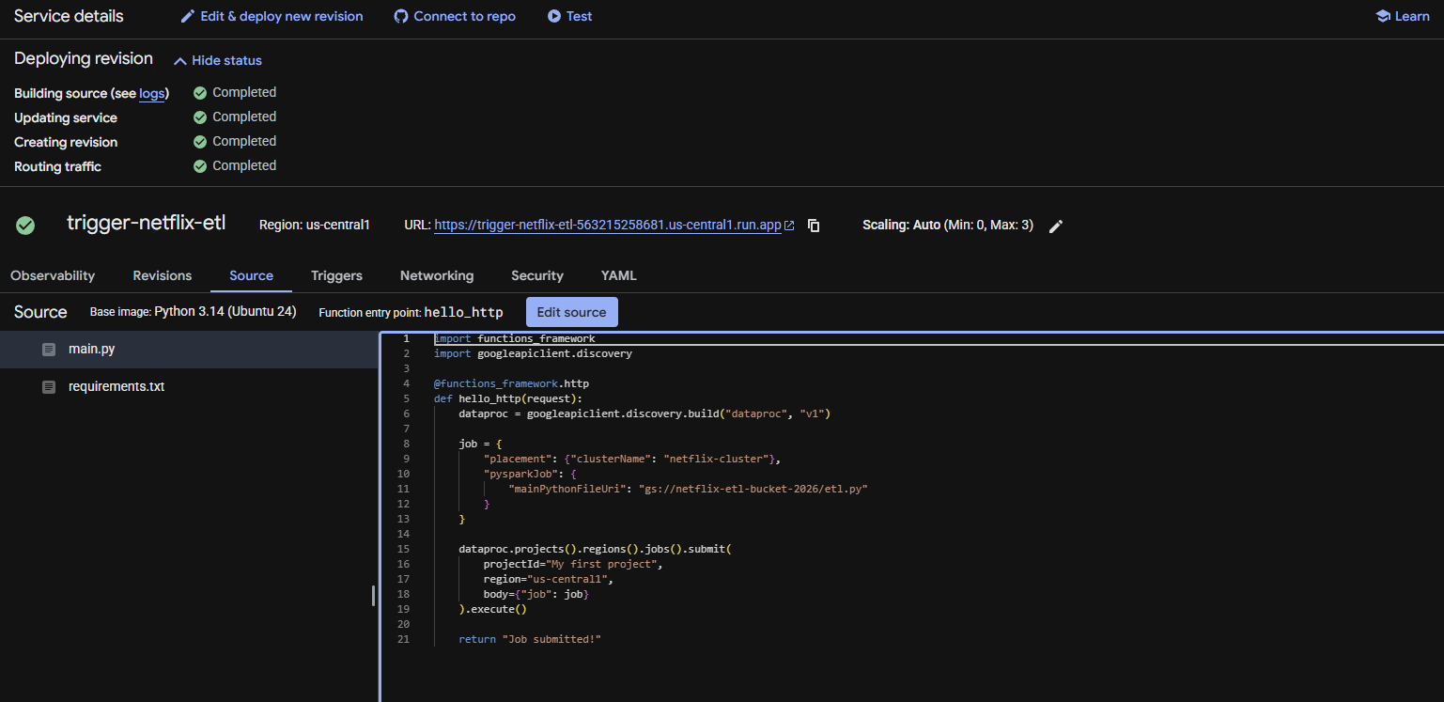
Picture – 5

  - Finally I set up a schedular so my job could be performed every day at 12 pm. Picture 6.

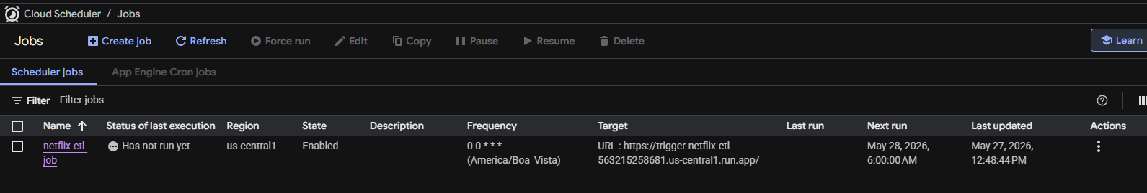

As far as I understand it’s extremely important so all services are created at the same region.

